1. **4-Bit Ripple Carry Adder**

*Aim:* To implement the $-Bit Ripple Carry Adder using logic gates.

*Description:* 4-bit ripple carry adder is used for the purpose of adding two 4-bit binary numbers. Ripple Carry Adder works in different stages. Each full adder takes the carry-in as input and produces carry-out and sum bit as output

*Logic circuit/Symbol:*

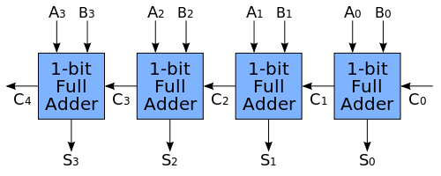

*Truth Table:*

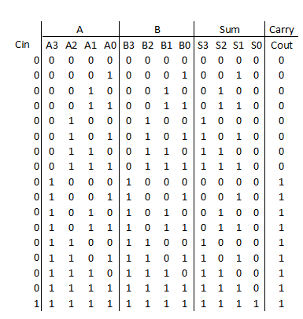

***Multisim Construction:***

*Components Required:* Interactive_digital_Constants, EX-OR gates, AND gates, OR gates, Probes.

*Procedure:*

1.Construct Four Full adders using the given Components

2.Connect the carry of the first adder as one of the input of the second adder.

3.Continue the second step upto the 4th adder and connect a probe to the carry of the 4th adder.

4.Connect probes to all the sums of the adders.

5.Observe the outputs for different input values.

*Multisim Circuit:*

